The JNS Encryption Algorithm

Software Requirements Specification

1/09/2014

Joel Ulahanna (62)
Sneha Varghese (57)
Neil Pereira (44)

Chapter | Topic | Page No.
1 | Introduction | 4
1.1 | Purpose | 4
1.2 | Scope | 4
1.3 | Definitions, Acronyms, and Abbreviations | 4
1.4 | References | 8
1.5 | Overview | 8
2 | General Description | 9
2.1 | Product Perspective | 9
2.2 | Product Functions | 9
2.3 | User Characteristics | 9
2.4 | General Constraints | 9
3 | Specific Requirement | 9
3.1 | External Interface Requirements | 9
3.1.1 | User Interface | 9
3.1.2 | Encryption Algorithms | 10
3.2 | Functional Requirements | 10
3.2.1 | Plaintext Input | 10
3.2.2 | Viewing Messages | 10
3.2.2.1 | Plaintext | 10
3.2.2.2 | Cipher text | 10
3.2.3 | View Console | 10
3.3 | Non function Requirement | 10
3.3.1 | - User Interface and Human Factors | 10
3.3.2 | Deployment Platform | 10
3.3.2.1 | - Software | 10
3.3.2.1.1 | Operating System | 11
3.3.2.1.2 | Graphics | 11
3.3.2.2 | Hardware | 11
3.3.3 | - Error Handling | 11
3.3.4 | Quality Issues | 11
3.4 | Software System Characteristics | 11
3.3.1 | Performance | 11
3.3.2 | Reliability | 11
3.3.3 | Availability | 11
3.3.4 | Security | 11
3.3.5 | Maintainability | 11
3.3.6 | Portability | 11
4 | System Models | 12
4.1 | Use case Model | 12
4.2 | Sequence Model | 13
4.3 | State Chart Model | 14
4.4 | Class Model | 15
4.5 | Activity Model | 16

1. Introduction.

1.1 Purpose
The purpose of the JNS Encryption Algorithm is to provide the following :
- Authentication – Providing ones identity before granting access.
- Privacy & Confidentiality – Ensure that outsiders cannot read data intended for specific parties.

- Integrity – Ensures that the message is not modified in any way before it arrives to intended recipient.

- Non-Repudiation – Ensuring that the message truly originates from the sender.

1.2 Scope
- The scope of the project is to provide faster encryption and decryption with the help of the proposed algorithm.

- Generation of graphs for the comparative analysis of the proposed algorithm, RSA algorithm and the MREAalgorithm based on their time complexity.

1.3 Definitions, Acronyms, and Abbreviations
1.3.1 Definitions
ENCRYPTION:
The process of converting plaintext into a something which is unreadable , except for the receiver is known as encryption.

DECRYPTION:
The process of converting cipher text(unreadable form) back to plaintext is called decryption.

ACTOR:

A use case diagram shows the interaction between the system and entities external to the system. These external entities are referred to as actors. Actors represent roles which may include human users, external hardware or other systems.

USE CASE:

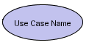
Use Cases describes the behavior of the system as seen from an actor’s point of view .Use Cases are depicted with an ellipse.
System boundary:
<<subsystem>>

A system boundary defines the scope of what a system will be. A system cannot have infinite functionality . A system boundary of a use case diagram defines the limits of the system. The system boundary is represented with a rectangle diagram.

Association:

Associations are used to link Actors with Use Cases, and indicate that an Actor participates in the Use Case in some form. Associations are depicted by a line connecting the Actor and the Use Case.

Aggregation:

A special form of association that are used to represent a wide range of connections among set of object.Is is denoted by a simple line with a diamond at the container end of the association.

Generalization:

Generalization is used when you find two or more use cases that have commonalities in behavior, structure, and purpose. When this happens, you can describe the shared parts in a new, often abstract, use case that is then specialized by child use cases.

Include:
<<include>>

It uses to include use cases that exibit additional features.

Extend :
<<extend>>

It is used for specifying exceptional behavior.

Class :
Name

Attribute

Operations

Each class is a collection of data and functions that manipulate the data. Each class is represented by rectangle sub-divided into 3 categories followed by name, attributes and operations.

Compositions:

It is a strong form of association. The lifetime of the part is dependent upon the whole.

Object:

Objects are entities that encapsulate state and behavior. Each object has an entity and is distinguishable from other objects.

Lifeline:

Lifeline is a time span of the object. They are vertical dash line that represents the existence of an object at a particular time.

Focus of control:

Active procedure on which object is active. It is depicted by vertical rectangle.

Types of message:

Synchronous:

The sender waits until the responder finishes.

Asynchronous:

The sender does not wait for anything from the responder, but it continues its own activity.

Flat:

The sender does not wait for anything from the responder and finishes its activity, the control is then passed to the responder.

State:

A simple state with no substructure.

Initial Node:

Start state. Indicates the starting state of the system.

Final Node:

Final State. Indicates the end of the activity

Fork/Join:

Fork represents that many activites can be parallely carried out.

Swimlanes:

Diagrams are partitioned according to the class who is responsible for carrying out the activities .They are represented as rectangles enclosing a group of actions.

    - Abbreviations

- RSA –Ron Rivest, Adi Shamir and Leonard Adleman encryption algorithm
- MREA– Modified RSA encryption Algorithm

1.4 References

[1] Daemen, J., and Rijmen, V.: The block cipher Rijndael. Proceedings of the Third International Conference on smart card Reseacrh and Applications, CARDIS'98, 1820, pp. 277-284, Berlin: Springer, (2000).

[2] Stallings, W.: Cryptography and Network Security, Prentice Hall, (2010).

[3] Daemen, J. and Rijmen, V.: The First 10 Years of Advanced Encryption. In IEEE Security and Privacy, vol. 8, pp. 72-74, November (2010).

[4] Federal Information Processing Standards Publications FIPS 197, Advanced Encryption Standard (AES), 26 Nov (2001).

[5] Fahmy, A., Shaarawy, M., El-Hadad, K., Salama, G., and Hassanain, K.: A Proposal For A Key-Dependent AES. 3rd International Conference: Sciences of Electronic, Technologies of Information and Telecommunications. Tunisia: SETIT (2005).

[6] Sagheer, A. M., Al-Rawi, S. S., Dawood., A. O.: Proposing of Developed Advance encryption Standard. Developments in E-systems Engineering (DeSE), pp197-202 (2011).

[7] Zhang, R., and Zhen, L.: A Block Cipher using key-dependent S-box and P-Box. ISIE 2008 IEEE International Symposium on Industrial Electronics, pp. 1463-1468 (2008).

[8] Krishnamurthy, G. N., and Ramasvamy, V.: Making AES Stronger:AES with Key Dependent S-Box. IJCSNS International Journal of Computer Science and Network Security, vol.8, pp. 388-398 (2008).

[9] Schneier, B.: Description of a New Variable Length Key, 64-Bit Block Cipher (Blowfish), Fast Software Encryption,” Cambridge Security Workshop Proceedings, pp. 191-204, Springer-Verlag (1994).

[10] Rukhin, A., et al.: A Statistical Test Suite for Random and Pseudorandom Number Generators for Cryptographic Applications. NIST Special Publication 800-22 (2001).

1.5 Overview
- This Software Requirements Specification (SRS) is the requirements work product that formally specifies Encryption and Decryption using JNS Encryption Algorithm which is the modified version of the RSA and MREA Algorithms.
- Requirements statements in this document are both functional and non-functional.
- These include a general description of the product, user characteristics, and general constraints of this system.
- This model demonstrates the development team's understanding of the business domain and serves to maximize the team's ability to build a system that truly does support the business.
- These requirements will allow the user to gainknowledge ,as to how different encryption algorithms differ from each other in terms of providing security.

2. General Description

2.1 Product Perspective
- The software will run as a standalone application.
- While the software is running, the user shall be able to select which component to input values. This incorporates the selection of any plaintext producing its resultant cipher text

2.1.1 System Interfaces
The system is intended to interface with a single user at any given time. The user is able to interact with the system using a graphical user interface.

2.1.2 User Interfaces
The user interface must provide the user an understandable and effective way for entering attributes into the system. Java will be used to create the graphical user interface for the system. At the top of the GUI is a drop-down panel that will display each of the encryption algorithms that may be used (including the RSA algorithm, MREA algorithm & the JNS Encryption algorithm). Below that is a text field that allows the user to enter the plaintext that is to be encrypted. Depending on the type of algorithm chosen, the user will also be given the option of choosing various options such as the various key or substitutions. At the bottom of the interface is a text area that displays the result of the cryptographic scheme or cipher text. Occupying the right side is a console area that displays any output that will attempt to give the user some insight into how the encryption schemes work.

2.2 Product Functions
- Encryption converts the input data in the garbled form so that no intruder can understand that form of data unless he/she is in possession of the secret key.
- Decryption converts the encoded message back to the plaintext.
- Generation of graphs based on the performance of the RSA algorithm , MREA algorithm and JNS algorithm.

2.4 General Constraints:
- Data
- The maximum input block size is 128 bits.
- The key size can be either 128,192 or 256 bit only.

- Language:
The application and the algorithm will be designed using JAVA language.

3. Specific Requirements

3.1 External Interface Requirements

3.1.1 User Interfaces
- Keyboard
- Mouse

3.1.2 Encryption Algorithms
The system must be able to allow the user to select from the following encryption schemes:
RSA algorithm, MREA algorithm, JNS Encryption algorithm.

- RSA Algorithm.
The encryption and decryption would be done using the traditional RSA algorithm.

- Modified RSA encryption Algorithm(MREA)
This algorithm uses four prime numbers for the key generation. Also makes uses of additional keys so as to increase the Security.

- Proposed Algorithm
In the proposed algorithm all the keys required for the algorithm will be computed and stored in the database and also the computation of the encryption and decryption process will be done with the help of GNU library.

3.2 Functional Requirements
3.2.1 Plaintext Input
The Input given by the user is a plaintext message , which will be encoded by our software.

3.2.2 Viewing Messages

3.2.3.1 Plaintext
The plaintext message is viewed that the user shall input.

3.2.3.2 Ciphertext
The encoded ciphertextis viewed by the user in one of a variety of forms that are used in encodings today, mainly the ASCII standard, decimal, hexadecimal, and binary.

3.2.3 View Console
The messages will be displayed to the user which will give them an insight into the inner workings of the algorithm.

3.3 Non-Functional Requirements
3.3.1 User Interface and Human Factors
Though the user shall access this system via a standalone application, the system will still function independently. All input fields will be aligned in the center of any panel that contains the component for ease of use reasons.

3.3.2 Deployment Platform

3.3.2.1 Software
Since the system runs as a standalone application, the user must have a recent version
of Java2 installed on their system.

3.3.2.1.1 Operating System
Because Java is used, the operating system will be irrelevant. The system will run on any OS that supports Java2, including, but not limited to, Windows, Linux, and MacOS.

3.3.2.1.2 Graphics
A graphical user interface is used to enhance usability and must be able to run
on display that supports 640x480 resolution or higher

3.3.2.2 Hardware
The system must run on all systems that support Java2.

3.3.3 Error Handling
The system must check to ensure that all values in fields are valid (if an input field expects a letter of the alphabet, then great pains must be taken to ensure that the user does not input a non-alphabetic character), and that numerical fields have values that lie within the specified range.

3.3.4 Quality Issues
The program should not halt or crash during execution. The program must not alter the state of the user’s system after closing. As far as security issues are concerned, no files on the user’s system are read or otherwise modified.

3.4 Software System Characteristics

3.4.1 Reliability
Since the algorithm used is much faster as compared to the original AES algorithm and since there are no known security flaws yet , the reliability of this software is high.

3.4.2 Availability
The software is available to any party wishing to access it and will be accessible via the products home page

3.4.3 Security
There are no known security flaws at this time.

3.4.4 Maintainability
The source code should be properly documented, so that new developers will be able to understand the code as easily as possible

3.4.5 Portability
Since Java is used as the development language, there should be few problems porting the software to new platforms. As an added bonus, as long as the platform contains a java-capable browser, the system will run as an applet.

4. System Models

4.1 Use Case Diagram

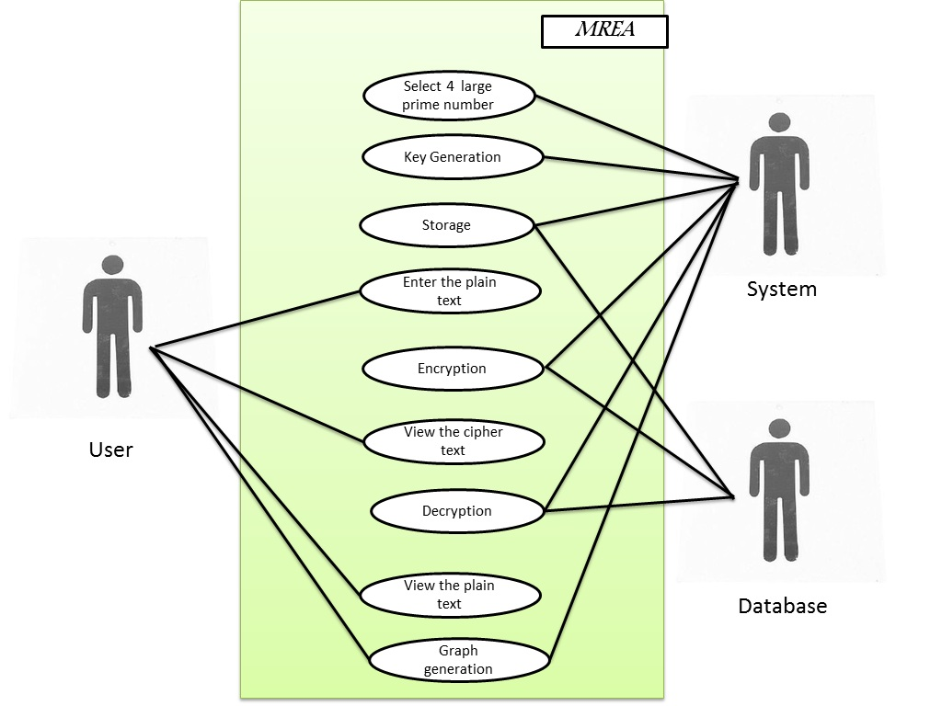

4.2 Sequence Diagram

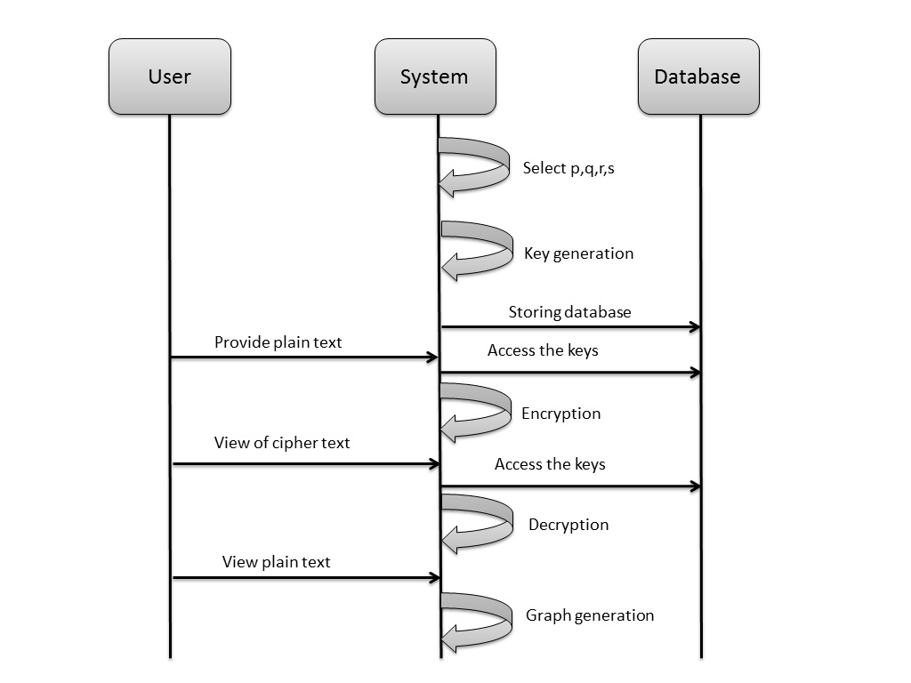

4.3 State Chart Model
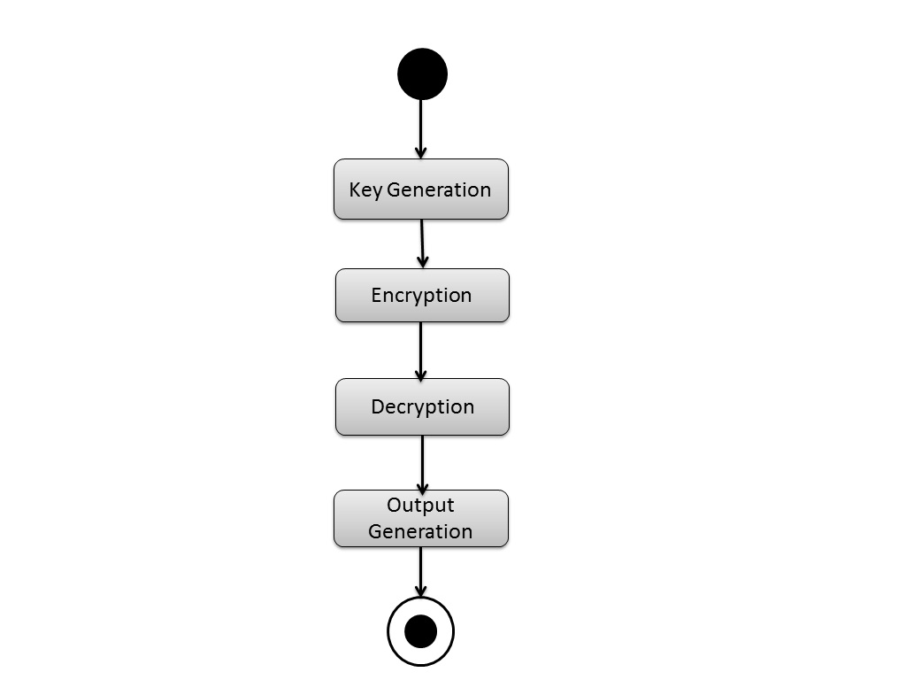

4.4 Class Diagram
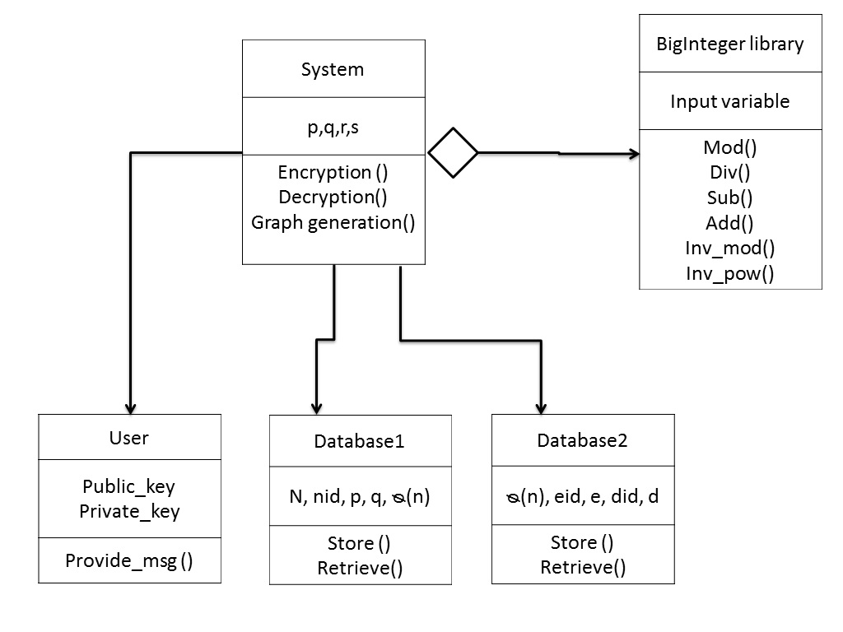

4.5 Activity Model

